Job title | Data Analyst Apprentice | Date September 2025
Reports to (title) | Performance Manager
Contract/Department | Central West | Revision 1
Location | Cheltenham / National / Hybrid

Job purpose
Describe the overall purpose of the job in two or three sentences.

EMCOR UK are offering a Data Analyst apprenticeship opportunity working on a large Total Facilities Management contract.
This role will support the Performance Manager in the design and management of all reporting requirements, enabling the account to highlight areas of improvement and achieve all operational targets.
You’ll gain valuable hands-on skills in data collection, cleaning, analysis, visualisation, and interpretation, while completing a Level 4 Data Analyst Apprenticeship, a nationally recognised qualification.

Duties/responsibilities/accountabilities/deliverables
List the main aspects of the job, with an emphasis on duties and responsibilities for junior roles, and accountabilities and deliverables for more senior roles.

- Design and development of dashboards; providing data to quantify and support topic specific reports.
- Produce account performance reports for approval by the Performance Manager.
- Proactively monitor the account performance throughout the month through data and trend analysis.
- Management of a common data environment (CDE) for the account.
- Work with both the operational and management team to ensure data quality within platform products, Power BI, SharePoint etc through regular updates and maintenance.
- Provide data 'mining' activities and transfer knowledge to the management team to aid decision making.
- Working closely with the Performance Manager to generate improvement initiatives across the account, including identifying opportunities that can improve efficiency of business processes.
- Ensure training is maintained and up to date at all times in EMCOR UK’s approved platform.
- Work with the CAFM team to enhance data quality and reporting within the system.

- Support the account team and performance manager with all other administrative duties as required.
- Working to the above whilst completing a Data Analyst Level 3 or 4 Apprenticeship.

Resource responsibilities
Indicate the typical number of direct reports, financial responsibility, control over subcontractors and any responsibility for assets, systems or outsourced services.

N/A

Person specification
Describe the knowledge, skills, qualifications, personality and experience required for the job.

- Analytical and data-driven mindset.
- A patient, resilient and "customer first" manner, being able to adapt and prioritise to provide successful outcomes.
- Solution focused with a positive outlook.
- Enthusiastic and willing to learn and develop. Working towards the qualification Level 4 Data Analyst Apprenticeship standard.
- GCSE (or equivalent) in English, Mathematics, and ICT at Grade C/4 or above.
- A strong working knowledge and competence of using Microsoft Office applications.
- Experience in using tools such as Microsoft Power BI and SharePoint highly desirable.

Other factors relevant to the job
Enter any additional information which the job holder would need to know, for example: requirement for UK-wide travel, shift patterns, night working, call outs etc.

- National Security Clearance should be held or obtainable.

Line Manager  Signature | 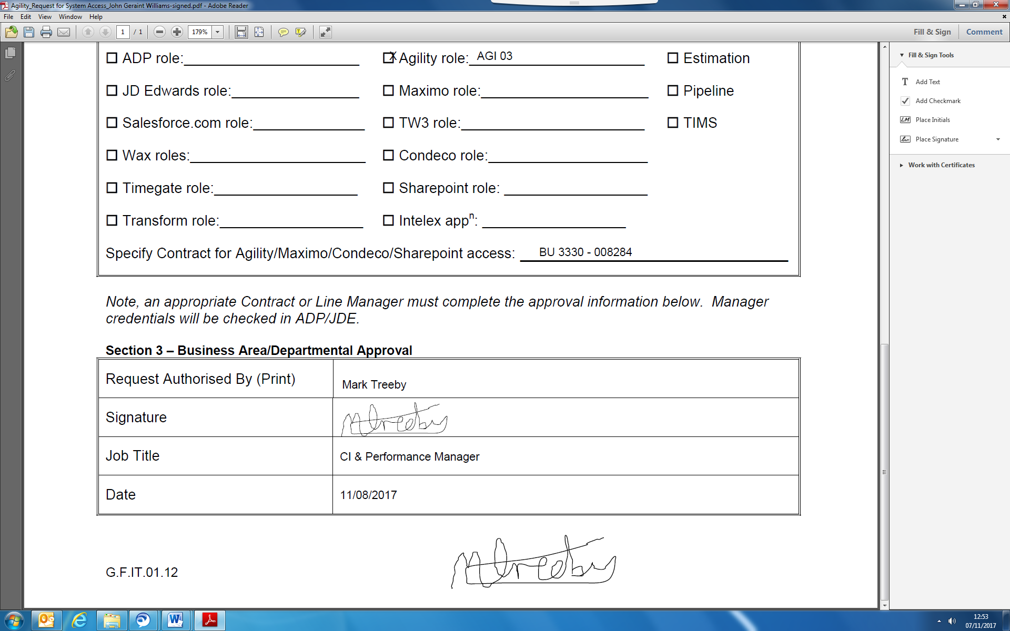
Print Name | Mark Treeby
Date | 11/09/2025

Job Holder
Signature
Print Name
Date

FOR HR USE ONLY:
Job Grade |  | EMCOR Competency Level |  | Training Profile UTC

